Ppppppc

Mmaximus.LLC

CIC № 41559243 str Jhemchujna 7, 46 Pearls, Odessa, Ukraine

Tel: +380963636093, +380636311633

office@mmaximus.org  
www.mmaximus.org

DOB   
Nationality   
Travel Passport ( Biometrical)   
Location   
Languages   
Seaman’s Book   
 STWC   
  
Non Smoker, No Visible Tattoos

KEY SKILLS

YACHT EXPERIENCE

PERSONAL INFO

фои

должность

**Тел, почта**

PpФ

ФОТО

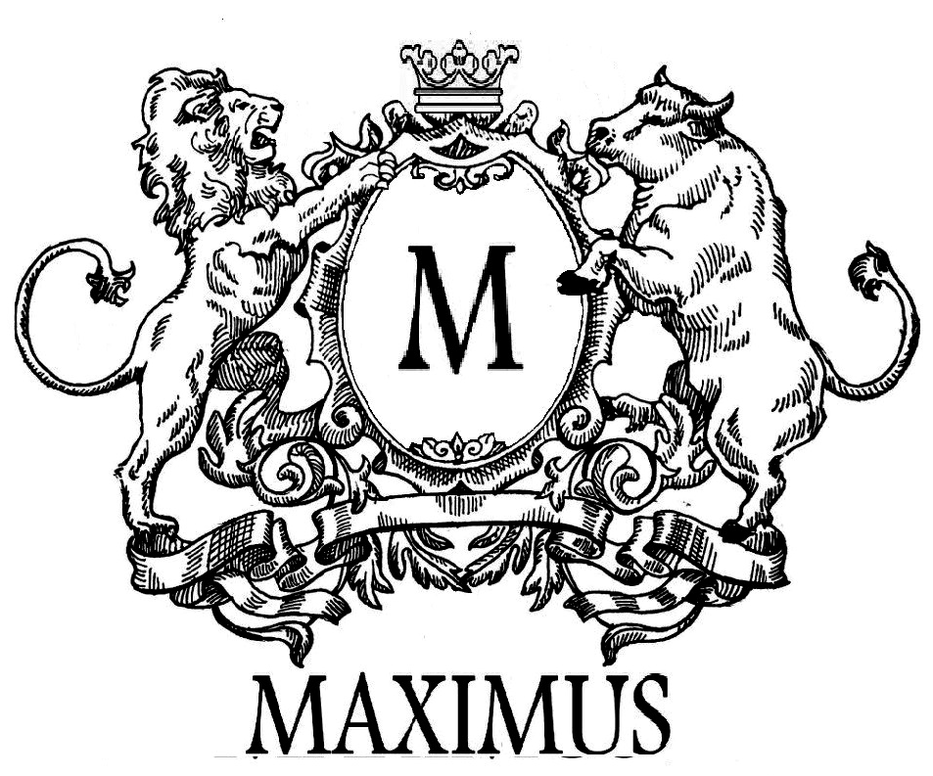



* **Position M/Y ………( private )**

Dates

**Duties** :

E

* Communication Skills
* Active Listening
* Stress Resistance
* Perform Under Pressure
* High Energy
* Advanced Verbal Communication Skills
* Anticipate Quest’s Needs
* Customer Service
* Team Player
* Attentive to details
* Problem Solver

SEA and LAND EXPIRIENCE

ABOUT ME

CERTIFICATES & EDUCATION